# Week 8 Task 2.2

A Spectrogram provides a time-frequency analysis of a song. This is a way of visually representing each note that is played. This will be compared to a waveform. Below is the same part of one song represented in a spectrogram and a waveform.

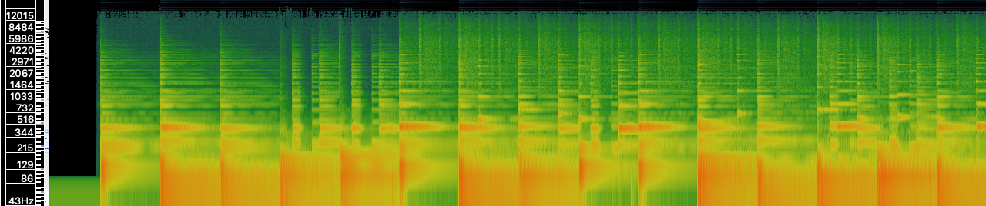

Figure 1: Eternity by Dee Yan Key, Spectrogram. (Key, 2018)

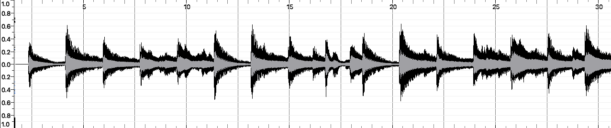Figure 2: Eternity by Dee Yan Key, Waveform. (Key, 2018)

Through viewing the visualisation of this acoustic data, it can be seen that the time-frequency (Spectrogram) shows a more detailed account of the change in notes over time. This is the yellow on green parts of the visual data. Compared to the waveform, that shows a sine wave visually representing the data. The data in the wave form is harder to distinguish the different notes that are within the song, allowing for more emphasis on volume. Time-frequency thus has an advantage over waveform by having a more detailed output of notes within a song, compared to the waveform that shows the volume of the notes plays.

# Bibliography

Key, D. Y. (2018). Eternity [Recorded by D. Y. Key]. http://freemusicarchive.org/music/Dee_Yan-Key/pondering_waltzes/11--Dee_Yan-Key-Eternity.